OOP Assessment Stage 6

Task 1: Shop Page For Customers
Create the following JFrame.
.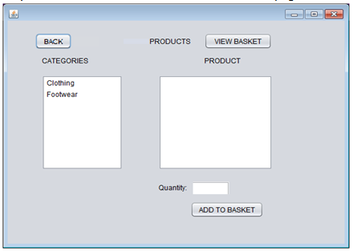
Note: the quantity field is a TextField.
The ‘Back’, ‘View Basket’ and ‘Add to Basket’ buttons should not do anything at this stage.
Make this new JFrame accessible from the Customer Home page via the ‘Browse Products’ button.

Your shop page should also load all the products from the database.
At this stage when you click on a Category you should see the appropriate Products within that Category on the 2nd List Box. Remember to create the .toString() override method within Products class and output a String (you may choose which) to display the products in a way you wish.

Task 2: Product Menu Page For Staff
Create the following new JFrame for Staff members:
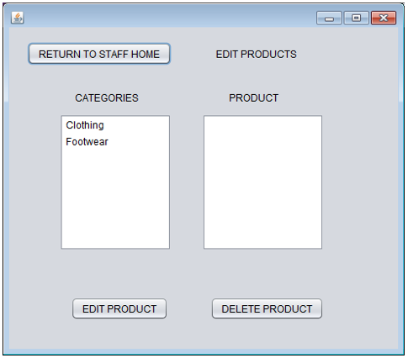
The ‘Return To Staff Home’, ‘Edit Product’ and ‘Delete Product’ buttons should not do anything at this stage.
Staff should be able to access this via their homepage -> 'Modify Products'

Again, at this stage Staff members should be able to see the Products within each category in the 2nd List Box.

